Tools for the class

- setup GitHub for saving your work

1. Creating an account
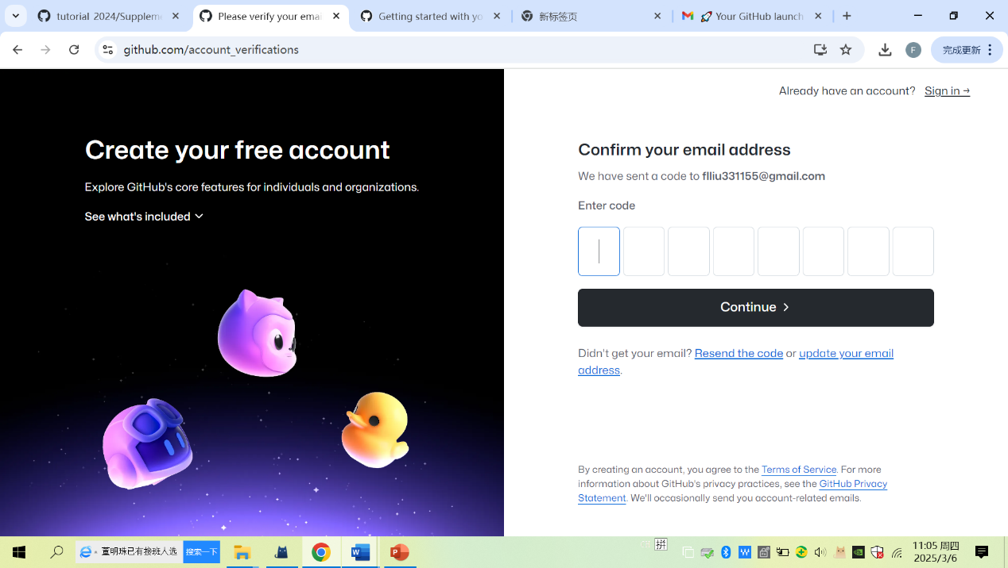
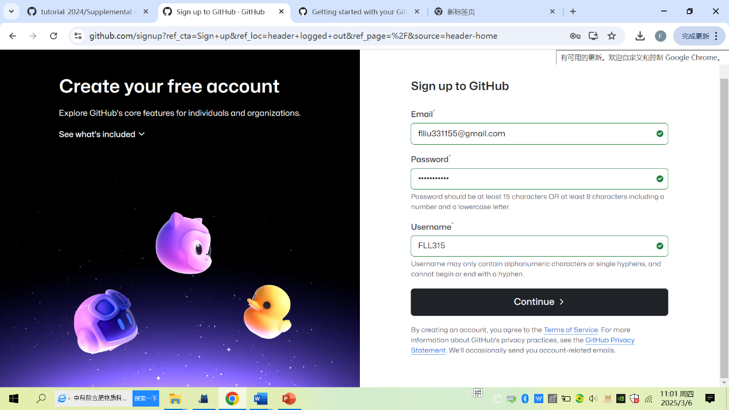

2. Configuring 2FA authentication

Setting >>password and authentication (scan OR code using google authenticator)
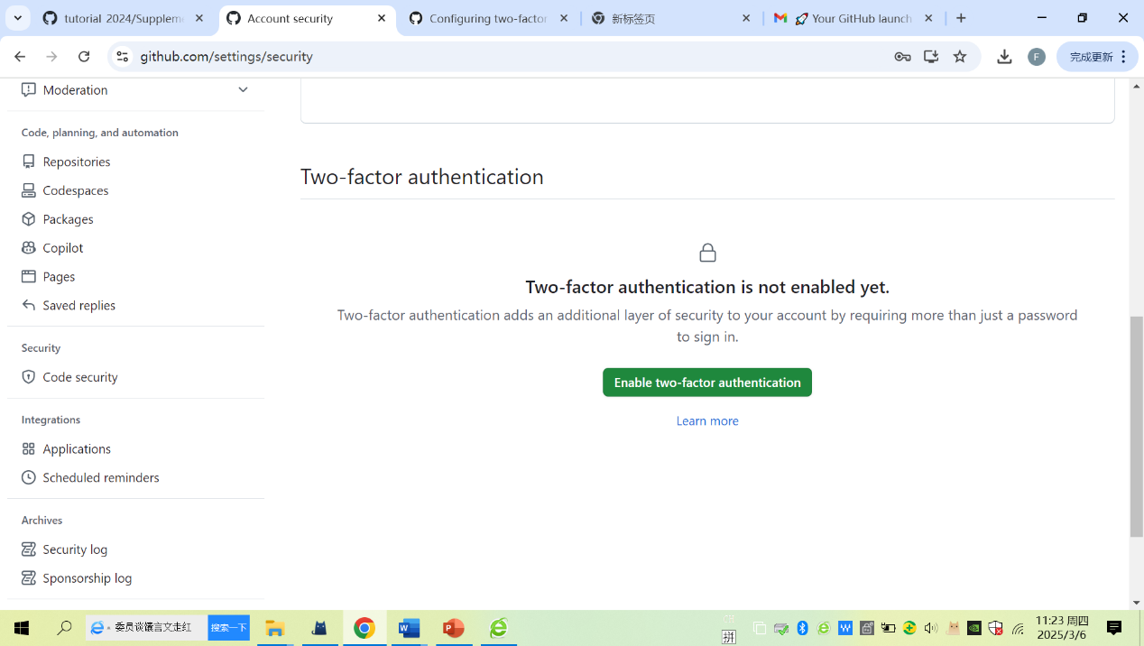

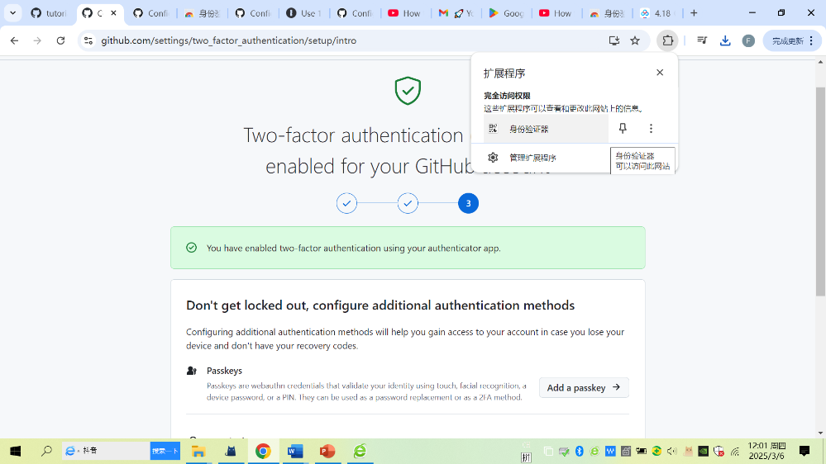

- Setup virtual env for installing rdataretriever/keras/tensorflow packages

1. install venv modulate in ubuntu
Run python3 --version，check whether python 3 is installed

python3 –version

run the following commands, install python3-venv for creating venv

sudo apt install python3-venv
sudo apt install python3-pip
pip3 install virtualenv

2. install reticulate package in Rstudio
Reticulated can be run in both RStudio and Python，install python packages via py_install()

Install.packages(‘reticulate’)
reticulate::virturalenv_create(“r-reticulate”) # reboost

3. setup virtual environment in Ubuntu
There are two ways to do, you can select one for your own system
One way is via RStudio

Open RStudio→tootls→global option→system

Another way is via Ubuntu terminal by running the following commands

sudo vim /usr/lib/R/etc/Renviron
RETICULATE_PYTHON="/home/tank/.virtualenvs/r-reticulate/bin/python"

4. activate virtual environment to install retriever、keras and tensorflow by two ways

In Ubuntu terminal，first activate virtual environment and then pip install retriever、keras、tensforflow√
In RStudio，using py_instwall() to install rdataretriver、keras、tensorflow

- Install and configure the databases of SQLite and PostgreSQL

1. SQLite (https://datawookie.dev/blog/2015/09/setting-up-odbc-for-sqlite-on-ubuntu/)

2. install and configure PostgreSQL

:~$ sudo lsb_release -a
:~$ sudo apt update
::~$ sudo sh -c 'echo "deb http://apt.postgresql.org/pub/repos/apt/ focal-pgdg
::~$ sudo apt update
::~$ sudo apt-get -y install postgresql postgresql-contrib
::~$ sudo service postgresql status

::~$ cat /etc/passwd
::~$ sudo -i -u postgres
postgres@ubuntu:~$ psql
postgres=# \l
postgres=# exit
postgres@ubuntu:~$ exit

::~$ cd /etc/postgresql/15/main
::/etc/postgresql/15/main$ sudo vim postgresql.conf
::/etc/postgresql/15/main$ sudo vim pg_hba.conf
::/etc/postgresql/15/main$ sudo service postgresql restart
::/etc/postgresql/15/main$ sudo service postgresql status
::~$ sudo -i -u postgres
postgres@ubuntu:~$ psql
postgres=# create role admin with
postgres-# login
postgres-# superuser
postgres-# createdb
postgres-# createrole
postgres-# inherit
postgres-# replication
postgres-# connection limit -1
postgres-# password 'admin';
postgres=# \q
postgres@ubuntu:~$ exit
::/etc/postgresql/15/main$
::/etc/postgresql/15/main$ sudo curl https://www.pgadmin.org/static/packages_pgadmin_org.pub | sudo apt-key add -
::/etc/postgresql/15/main$ sudo sh -c 'echo "deb https://ftp.postgresql.org/pub/pgadmin/pgadmin4/apt/$(lsb_release -cs) pgadmin4 main" > /etc/apt/sources.list.d/pgadmin4.list & apt update'
::/etc/postgresql/15/main$ sudo apt install pgadmin4-web
::/etc/postgresql/15/main$ sudo sh -c 'echo "deb https://ftp.postgresql.org/pub/pgadmin/pgadmin4/apt/focal pgadmin4 main" > /etc/apt/sources.list.d/pgadmin4.list'
::/etc/postgresql/15/main$ sudo /usr/pgadmin4/bin/setup-web.sh
Email address: flliu513@163.com
pgAdmin 4 - Application Initialisation
::/etc/postgresql/15/main$ sudo ufw allow 80/tcp
::/etc/postgresql/15/main$ sudo ufw enable
::/etc/postgresql/15/main$ sudo ufw status

- make a sure that R’s package of qgisprocess work

compile postgis-3.4.1
tar zxvf postgis-2.1.2.tar.gz
cd postgis-2.1.2
./configure --with-pgconfig=/usr/local/pgsql/bin/pg_config
make
make install

https://trac.osgeo.org/postgis/ticket/5222
SELECT * FROM pg_available_extensions WHERE name LIKE 'postgis';
CREATE EXTENSION postgis_raster SCHEMA public VERSION unpackaged;
CREATE EXTENSION postgis_topology SCHEMA topology VERSION unpackaged;

Install saga 9.3.1

1. first needing to install wxwidgets3.2 as follows:
https://juejin.cn/post/7283798844236218403
https://launchpad.net/~hrzhu/+archive/ubuntu/wxwidgets3.2-backport

Adding this PPA to jemmy system
sudo add-apt-repository ppa:hrzhu/wxwidgets3.2-backport
sudo apt update
install via terminal or manual synati
sudo apt-get install libwxbase3.2-0-unofficial \
libwxbase3.2unofficial-dev \
libwxgtk3.2-0-unofficial \
libwxgtk3.2unofficial-dev \
wx3.2-headers \
wx-common \

2. second install download saga

1) Install saga 9.3.1
sudo add-apt-repository ppa:johanvdw/saga-gis
sudo apt-get install saga

2) saga 9.3.1.tar.gz and compile it
https://sourceforge.net/p/saga-gis/wiki/Binary%20Packages/

git clone git://git.code.sf.net/p/saga-gis/code saga-gis-code
cd /saga-gis-code
mkdir build
cd build
cmake ../saga-gis -DCMAKE_BUILD_TYPE=RELEASE -DWITH_TRIANGLE=OFF -DWITH_SYSTEM_SVM=ON -DWITH_DEV_TOOLS=OFF
cmake --build . --config Release
sudo cmake --install .

